Online appendices detailing the robustness of empirical analyses are  
paramount but they never let readers explore all reasonable researcher  
degrees of freedom. [Simonsohn, Simmons and Nelson](https://papers.ssrn.com/sol3/papers.cfm?abstract_id=2694998) suggest  
a ‘specification curve’ that allows readers to eyeball how a main coefficient  
of interest varies across a wide arrange of specifications. I build on this idea  
by making it interactive: A shiny-based web app enables readers to explore the  
robustness of findings in detail along the whole curve.

Following up on [two blog articles](https://joachim-gassen.github.io/2019/04/11264-regressions-in-one-tidy-plot/)  
that introduced the in-development  
‘rdfanalysis’ package, the app is new extension of this package.  
In essence, it let’s you change the research design choices that you want  
to display and then redraws the curve on the fly.

In its simple version, it just needs a data frame with each row containing  
an estimate and its choices. In most cases, you also want to include lower and  
upper bounds of the estimate as well so that the specification curve can  
display a nice confidence interval ribbon. As an example, the first few rows  
of data used in the example below look as follows:

library(rdfanalysis)

load(url("<https://joachim-gassen.github.io/data/rdf_ests.RData>"))

kable(head(ests), format.args = list(digits = 3))

| **na.omit** | **idvs** | **outlier_tment_style** | **outlier_cutoff** | **model_type** | **feffect** | **cluster** | **est** | **lb** | **ub** |
| --- | --- | --- | --- | --- | --- | --- | --- | --- | --- |
| yes | gdp_only | win | 0 | level-level | none | none | 0.362 | 0.3466 | 0.3783 |
| no | gdp_only | win | 0 | level-level | none | none | 0.386 | 0.3737 | 0.3983 |
| yes | gdp_school | win | 0 | level-level | none | none | 0.131 | 0.1159 | 0.1452 |
| no | gdp_school | win | 0 | level-level | none | none | 0.075 | 0.0644 | 0.0855 |
| yes | gdp_ue | win | 0 | level-level | none | none | 0.370 | 0.3543 | 0.3860 |
| no | gdp_ue | win | 0 | level-level | none | none | 0.325 | 0.3116 | 0.3378 |

This is the type of data that exhaust_design() from the rdfanalysis package  
will generate. If you create your own data, you need to inform  
plot_rdf_spec_curve() which columns in your data frame contain choices. You  
do this by setting attribute in the data frame. In the case above, choices are  
included in columns 1 to 7. So that you would set the attribute as follows:

attr(ests, "choices") <- 1:7

Once you have such a data frame, you can plot your specification curve:

attr(ests, "choices") <- 1:7

plot_rdf_spec_curve(ests, "est", "lb", "ub")

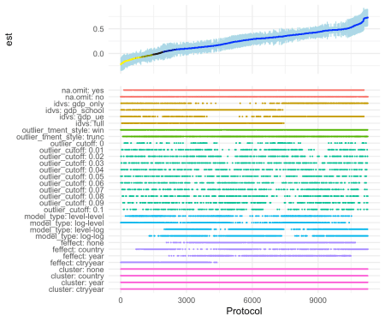

Nice. But how does one create the interactive display? Easy. Just call  
shiny_rdf_spec_curve(), giving your data and the additional parameters that  
you would hand over to plot_rdf_spec_curve() as a list:

shiny_rdf_spec_curve(ests, list("est", "lb", "ub"))

You will see that the app will take a while to display the initial specification  
curve. This is because it is based on 11,264 specifications. Once you start to  
drill down, the app will become more responsive.

When you focus on only a few specifications you might think “Hey this is nice but  
I would rather like to see the actual regression results for these cases”.  
This can be done! You can use the workflow of the rdfanalysis package so that  
the app will present the actual model results as soon as you zoomed in on a handful  
of specifications. While you at it you can also specify your preferred  
specification (e.g., the one that you presented in your paper).

design <- define_design(steps = c("read_data",

"select_idvs",

"treat_extreme_obs",

"specify_model",

"est_model"),

rel_dir = "vignettes/case_study_code")

shiny_rdf_spec_curve(

ests, list("est", "lb", "ub"),

design, "vignettes/case_study_code",

"<https://joachim-gassen.github.io/data/wb_new.csv>",

default_choices = list(na.omit = "no",

idvs = "full",

outlier_tment_style ="win",

model_type = "level-log",

outlier_cutoff = 0,

feffect = "ctryyear",

cluster = "ctryyear"))

Please note that the code above will only run when you have forked the  
rdfanalysis repo and set the working directory to its root.

Finally, you can add a title and a short info text by setting the title and  
abstract parameters and, voilà: Your [interactive and exhaustive robustness  
section](https://jgassen.shinyapps.io/shiny_rdf_spec_curve).

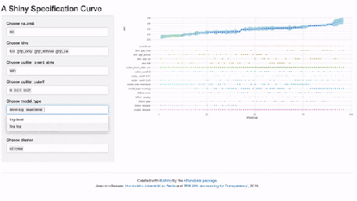

Kudos to Nate Breznau for bringing up the idea to use shiny to visualize the  
specification curve. Feel free to use the in-development [‘rdfanalysis’ package](https://joachim-gassen.github.io/rdfanalysis) to exhaust the researcher degrees of freedoms in your own projects. If you have remarks about this project, I would love to hear from you.